**Assignment 4**

1.Create an array of integers and use a for loop to print out each element of the array.

<https://codeshare.io/eV6N0J>

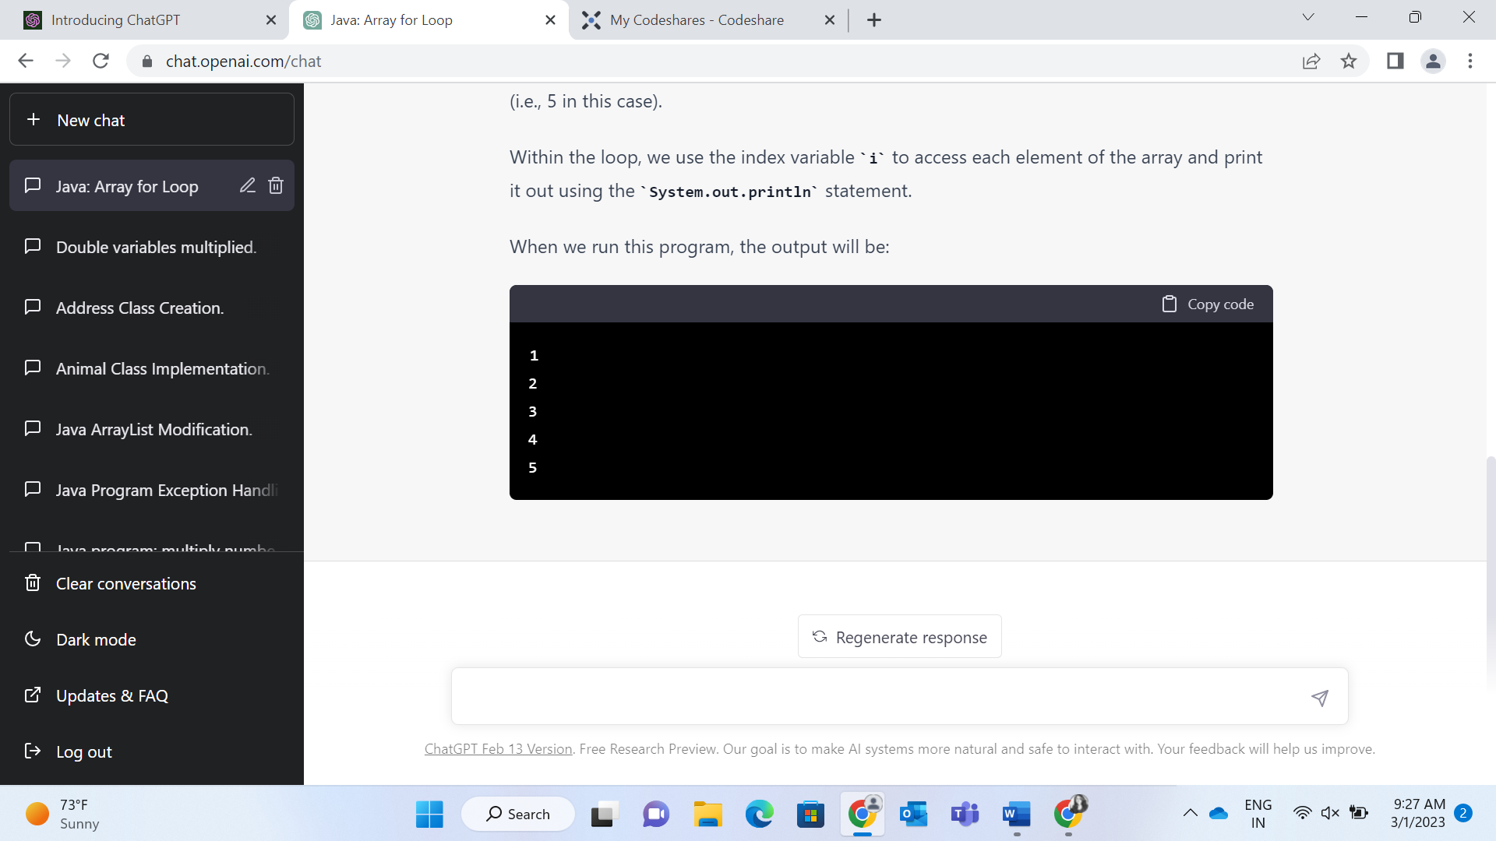

2.Create an array of strings and use a for-each loop to print out each element of the array.

<https://codeshare.io/3AbM9z>

3.Create an array of doubles and use a while loop to print out each element of the array.

<https://codeshare.io/Ad1Nvl>

4.Create an array of characters and use a do-while loop to print out each element of the array.

<https://codeshare.io/EBE16O>

5.Create an array of integers and use the Arrays class method sort() to sort the array in ascending order.

<https://codeshare.io/eV6NwJ>

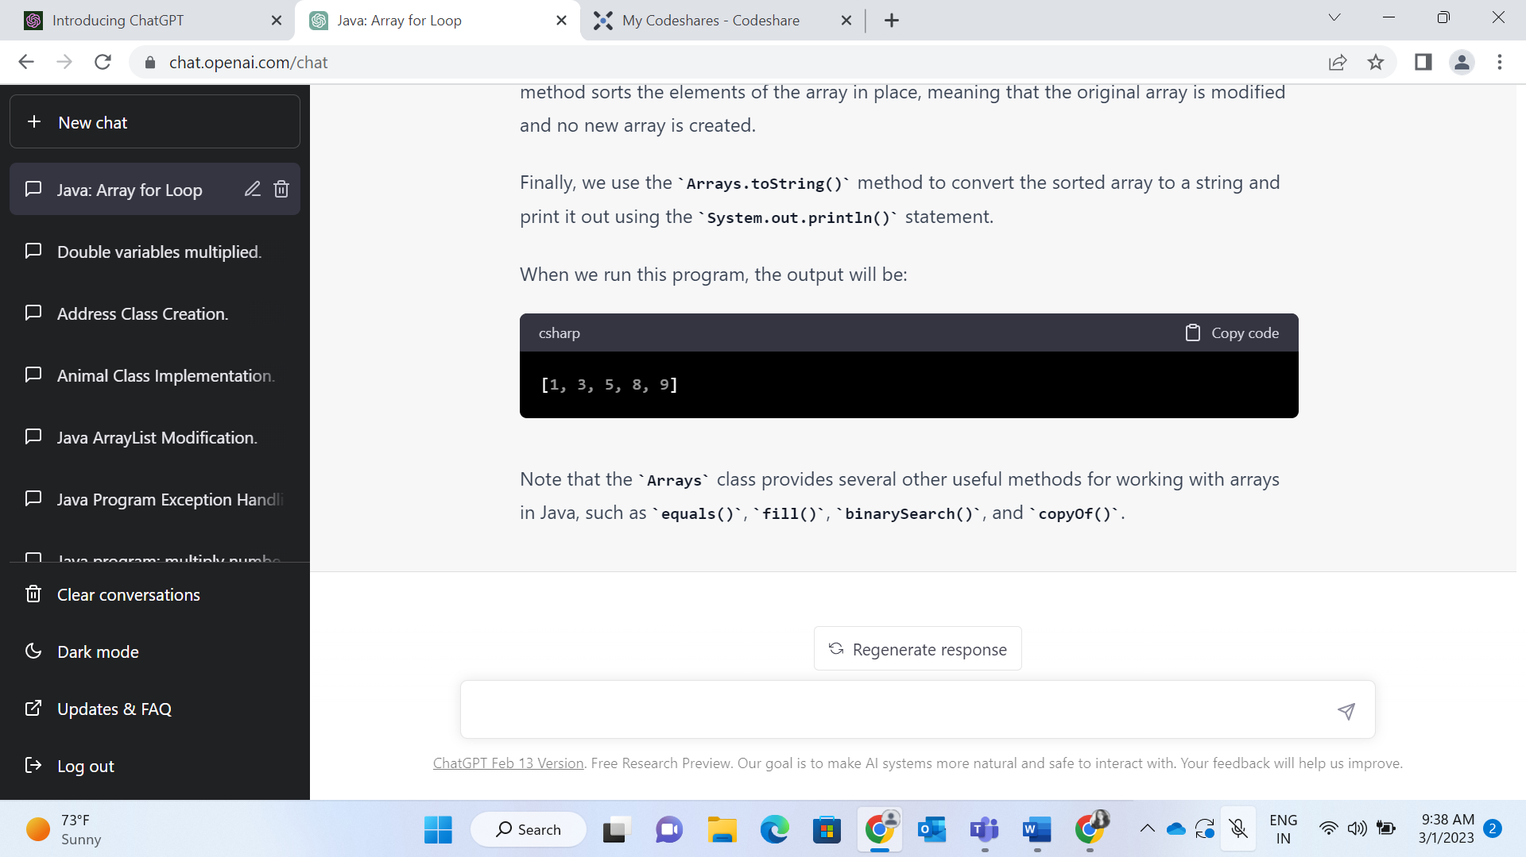

6.Create an array of strings and use the Arrays class method binarySearch() to find the index of a specific string in the array.

<https://codeshare.io/oQ3gdY>

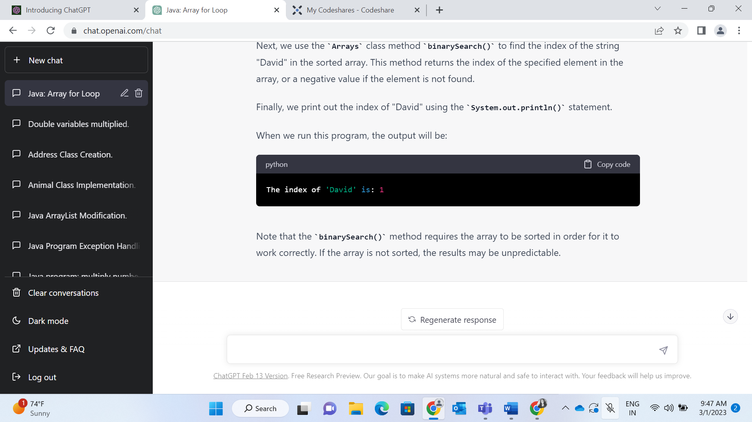

7.Create a string and use the String class method split() to split the string into an array of substrings.

<https://codeshare.io/1Y8M17>

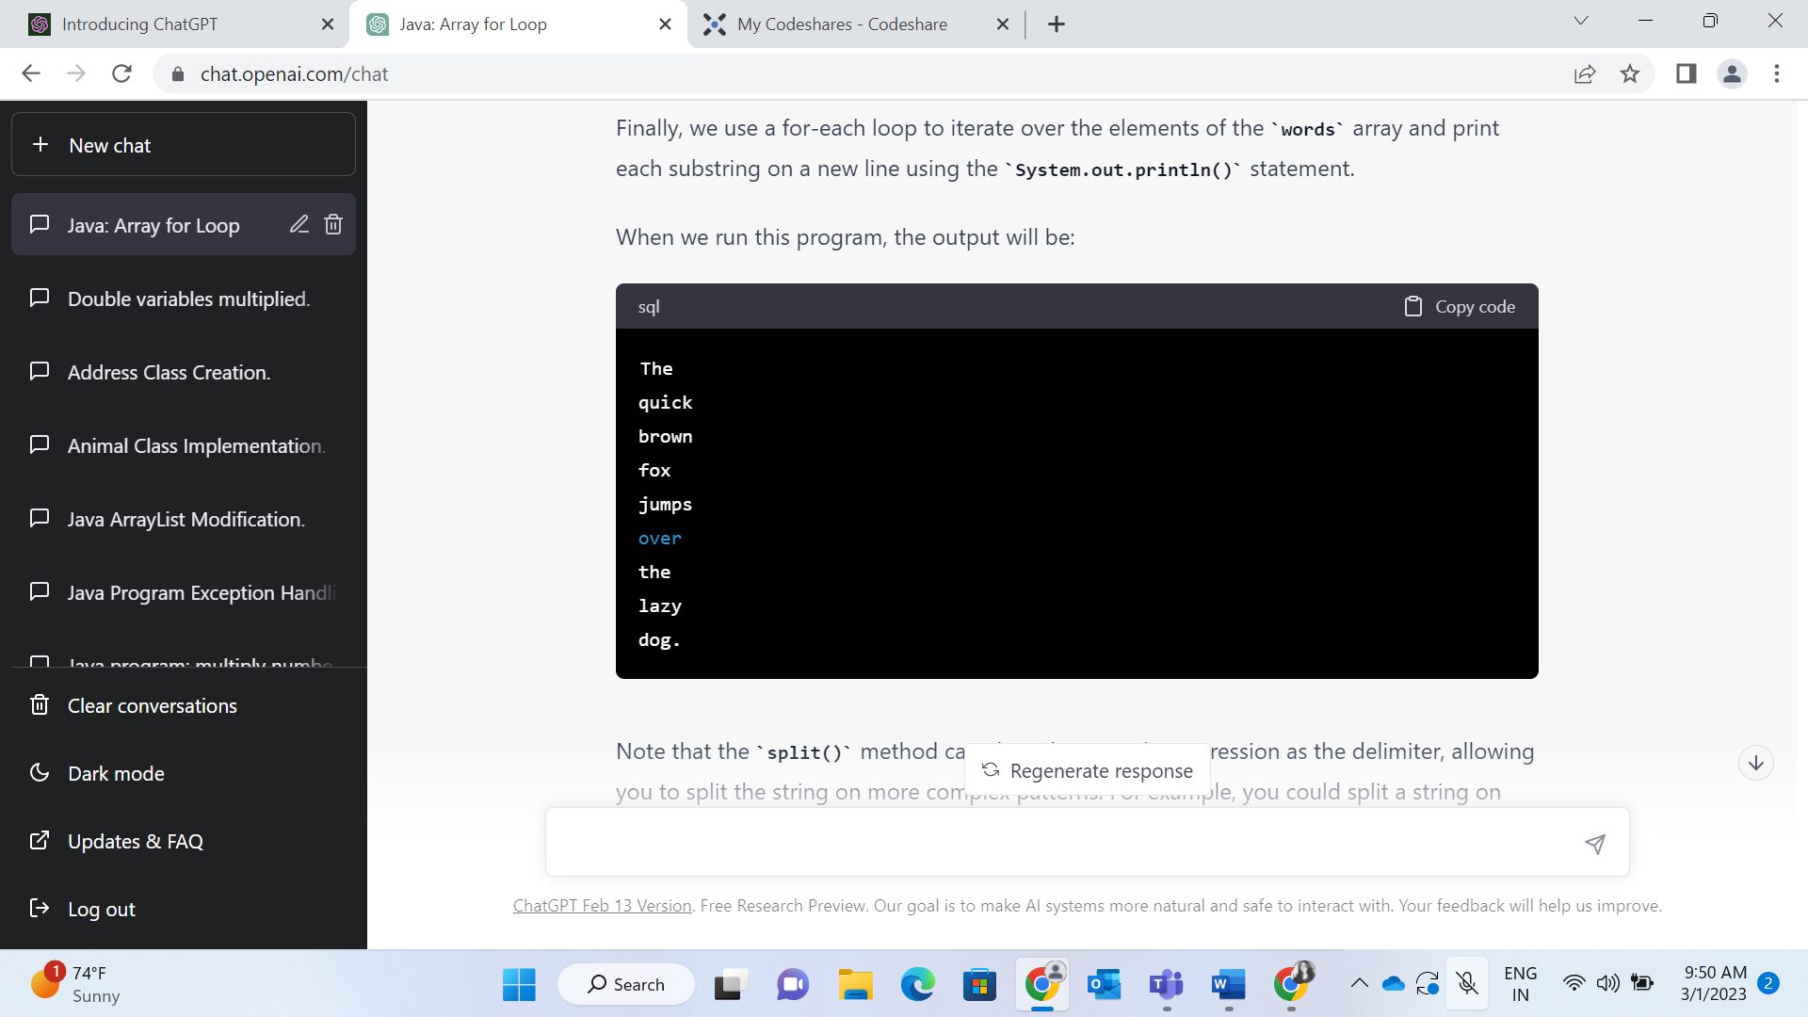

8.Create a string and use the String class method replace() to replace a specific substring in the string with a new substring.

<https://codeshare.io/VZE0P9>

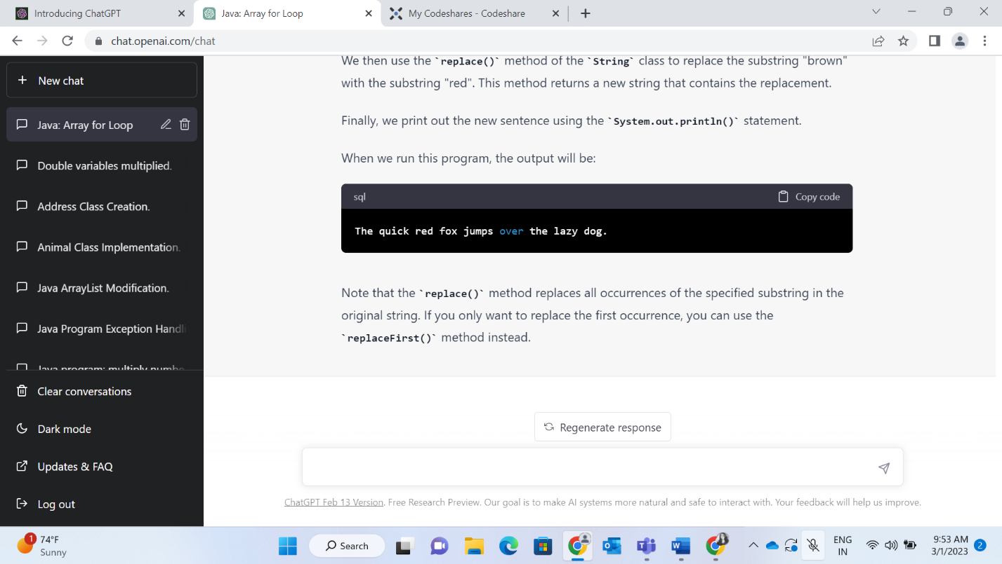

9.Create a string and use the String class method substring() to extract a portion of the string

<https://codeshare.io/QnE0Qq>

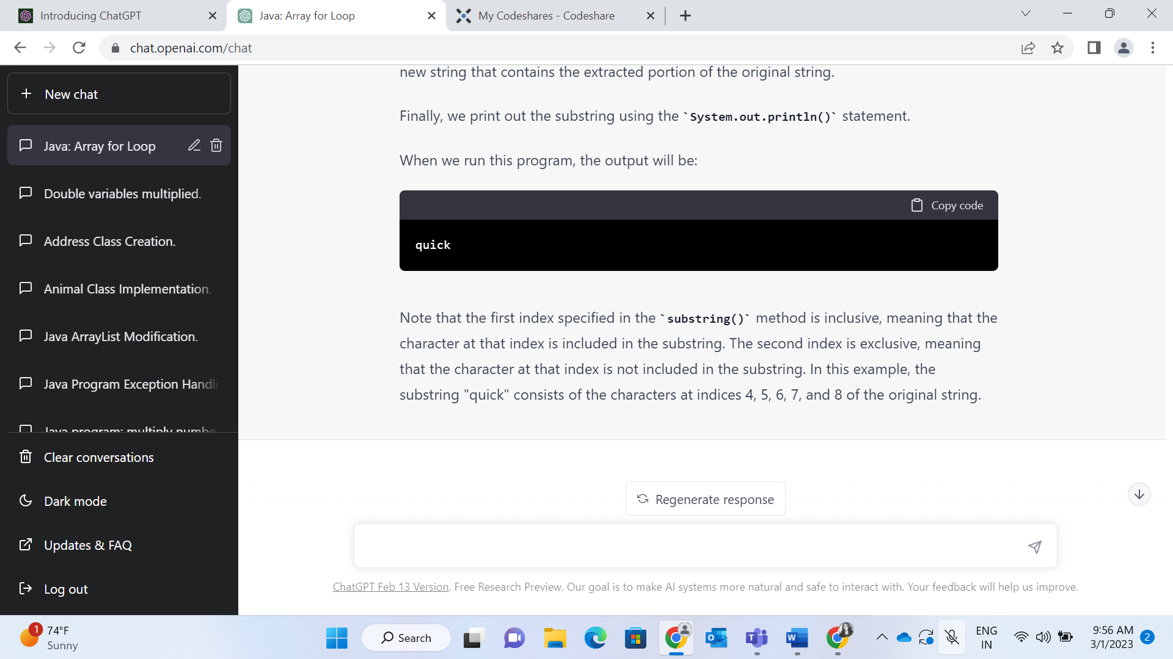

10.Create a string and use the String class method length() to find the length of the string.

<https://codeshare.io/3AbMx6>

